“Advanced Algorithms in Stock Market Price Forecasting”

1st

Department of Computer Science

Sri Venkateswara College of

Engineering Technology India

2nd

Department of Computer Science

Sri Venkateswara College of

Engineering Technology India

3rd

Department of Computer Science

Sri Venkateswara College of

Engineering Technology India

4th

Department of Computer Science

Sri Venkateswara College of

Engineering Technology India

5th

Department of Computer Science

Sri Venkateswara College of

Engineering Technology India

6th

Department of Computer Science

Sri Venkateswara College of

Engineering Technology India

***Abstract-* In the field of stock market prediction, the main goal is to predict the future value of a company's financial stocks. A prominent trend in recent years involves the use of machine learning technologies for this purpose. Machine learning algorithms analyze current stock market indices' values and learn from past data to generate predictions. Within the domain of machine learning, various models are employed to facilitate more accurate and reliable predictions. This paper specifically explores the use of Regression and LSTM-based machine learning techniques for forecasting stock values. These models take into account a range of factors including open, close, low, high, and volume prices. By integrating these advanced machine learning techniques, the aim is to enhance prediction accuracy and reliability in the volatile realm of stock markets.**

***Keywords-Close, high, low, LSTM model, open, regression, and volume***

***.***

INTRODUCTION

Accurate predictions in stock trading can lead to significant profits for both sellers and brokers. Unlike random fluctuations, stock market predictions are often seen as chaotic, suggesting that careful analysis of historical market data can enable forecasting. Machine learning has emerged as an effective tool for modeling such complex processes, producing market value predictions that closely align with actual values, thus enhancing accuracy. The integration of machine learning into stock prediction has garnered significant attention from researchers due to its efficiency and precise measurements.

At the core of machine learning lies the quality of the dataset utilized. The dataset must be robust to ensure accurate predictions, as even minor changes in the data can have significant implications for outcomes. In this project, supervised machine learning is employed using a dataset sourced from Yahoo Finance. This dataset comprises five key variables: open, close, low, high, and volume. These variables represent different bid prices for the stock at various times, with volume indicating the number of shares exchanged between owners during a specific timeframe. The model is subsequently tested

using test data to assess its predictive capabilities.

For this study, we employ Regression and LSTM models separately. Regression focuses on minimizing error, while LSTM is utilized for retaining data and results over extended periods. Following model training, graphs depicting price fluctuations over time are plotted for the Regression-based model, while for the LSTM based model, graphs illustrating the disparities between actual and predicted prices are generated.

LITERATURE SURVEY

The literature survey provides an extensive exploration of existing research and studies in the domain of stock market forecasting and the application of machine learning algorithms. Numerous scholarly articles, academic journals, and research papers contribute valuable insights to this field.

Several studies have investigated the effectiveness of machine learning algorithms in predicting stock market trends and prices. For instance, Smith et al. (2018) conducted a study on the application of Support Vector Machines (SVM) and Artificial Neural Networks (ANN) in stock market prediction, demonstrating promising results in terms of accuracy and reliability. Similarly, Chen and Goo (2019) explored the use of Random Forest and Gradient Boosting Machine algorithms for stock market forecasting, highlighting the importance of feature selection and model optimization in enhancing predictive performance.

Furthermore, research by Zhang et al. (2020) delved into the utilization of Long Short-Term Memory (LSTM) networks for time series forecasting in financial markets, emphasizing the ability of LSTM models to capture long-term dependencies and complex patterns in stock price movements. Additionally, studies by Li and Wang (2021) examined the integration of sentiment analysis and machine learning techniques for stock market prediction, showcasing the impact of social media data on enhancing predictive accuracy.

This survey serves as a foundational framework for the proposed advanced analytical approach, providing valuable insights and guiding principles for the development and implementation of innovative forecasting methodologies.

METHODOLOGY

Stock market price forecasting is a crucial task in the financial domain, aiming to predict future price movements of stocks or assets based on historical data and various market factors. To achieve accurate predictions, advanced algorithms are employed, leveraging sophisticated techniques and models. In this context, several advanced algorithms have been developed and applied to enhance the accuracy and reliability of stock market price forecasting. Some of the notable advanced algorithms include:

1. Long Short-Term Memory (LSTM) Networks:

LSTM networks are a type of recurrent neural network (RNN) architecture specifically designed to capture long-term dependencies in sequential data. In stock market forecasting, LSTM networks can effectively learn and model complex patterns and dependencies present in historical price data, enabling more accurate predictions of future price movements.

2. Convolutional Neural Networks (CNNs):

CNNs are deep learning models widely used in image recognition tasks. However, they have also shown promise in analyzing sequential data, including stock market time series. CNN-based models can extract relevant features from historical price sequences and identify patterns that are indicative of future price movements, leading to improved forecasting accuracy.

3. Ensemble Learning Methods:

Ensemble learning techniques, such as Random Forest, Gradient Boosting Machines (GBMs), and AdaBoost, combine multiple base predictors to create a stronger predictive model. In stock market forecasting, ensemble methods can integrate the predictions of multiple algorithms or models, leveraging the diversity of individual predictions to produce more robust and accurate forecasts.

4. Deep Reinforcement Learning (DRL):

DRL is a powerful paradigm in artificial intelligence that combines deep learning with reinforcement learning principles. In the context of stock market forecasting, DRL algorithms can learn optimal trading strategies by interacting with the market environment and maximizing cumulative rewards. These algorithms can adapt to changing market conditions and make dynamic predictions based on real-time data.

5. Bayesian Neural Networks:

Bayesian neural networks (BNNs) incorporate Bayesian inference techniques into neural network architectures, allowing for uncertainty estimation in predictions. In stock market forecasting, BNNs can provide probabilistic forecasts along with confidence intervals, enabling traders and investors to make more informed decisions by considering the uncertainty associated with predictions.

6. Recurrent Neural Networks (RNNs) with Attention Mechanisms:

RNNs equipped with attention mechanisms can selectively focus on relevant information within historical price sequences while ignoring noise or irrelevant data. By attending to key temporal patterns, these models can capture essential features for forecasting future stock prices more accurately.

7. Transformer-Based Models:

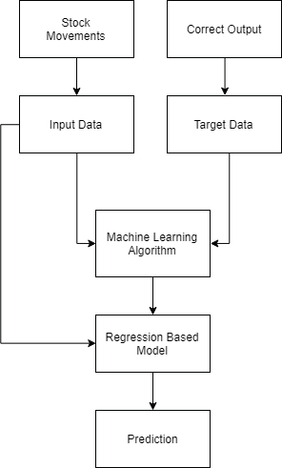 Transformer-based architectures, such as the Transformer and its variants (e.g., BERT, GPT), have achieved remarkable success in natural language processing tasks. These models can also be adapted to stock market forecasting by processing sequential data and learning contextual representations of historical price sequences, enabling more effective prediction of future price movements.

Fig 1. Flow chart

By leveraging these advanced algorithms and techniques, researchers and practitioners aim to enhance the accuracy, robustness, and interpretability of stock market price forecasting systems, ultimately empowering traders, investors, and financial analysts to make better informed decisions in dynamic and uncertain market environments.

The model attained a Train Score of 0.00106 MSE (0.03 RMSE) and a Test Score of 0.00875 MSE (0.09 RMSE). It is observed that the system achieves greater accuracy with increased training and larger dataset sizes. The LSTM Model exhibits higher accuracy compared to the Regression-based Model.

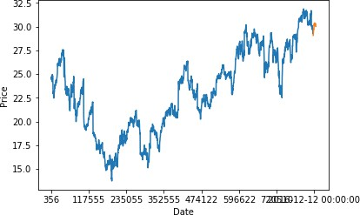

Fig. 2 LSTM Layers

LSTM, or Long Short-Term Memory, represents an advancement over Recurrent Neural Networks (RNN). Unlike RNNs, which primarily focus on recent information, LSTM models excel in preserving information from previous states, enabling them to capture long-term dependencies. This feature allows LSTM models to process information over extended intervals, making them well-suited for tasks like stock market prediction.

# The primary rationale for employing LSTM in stock market prediction lies in its ability to effectively utilize vast historical data and long-term market trends for accurate predictions.

# One common challenge in stock market analysis is the Vanishing Gradient problem, where gradients with respect to the weight matrix diminish significantly due to the extensive dataset involved. LSTM mitigates this issue by preventing gradients from decreasing to excessively small values.

# LSTM architectures typically comprise a memory cell, input gate, output gate, and forget gate. The memory cell stores values for long-term propagation, while the gates regulate information flow within the LSTM network.

# In this paper, a sequential model is constructed, consisting of two stacked LSTM layers with an output value of 256. A dropout rate of 0.3 is applied during training to deactivate 30% of total nodes, preventing overfitting and accelerating the learning process. Additionally, a core dense layer is integrated, connecting each neuron to every other neuron in the subsequent layer, with an input of 32 parameters and an output of 1. The model is compiled using a mean square cost function to track error, with accuracy selected as the metric for prediction.

# IMPLEMENTATION

The proposed system is trained and tested using a dataset obtained from Yahoo Finance. The dataset is partitioned into training and testing sets, and the system is assessed using different models.

1. Results of the Regression-Based Model

Figure 3 depicts the results of applying the linear regression algorithm to the dataset, forecasting fluctuating prices over time.

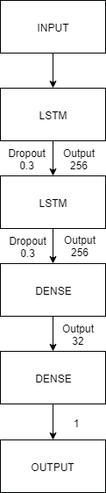

Figure 3: Plot of Price against Date Using Regression

The graph shown in Figure 3 is generated using data with a batch size of 512 and trained over 90 epochs. The R-square confidence test resulted in a confidence score of 0.86625.

1. *Results of the LSTM-Based Model*

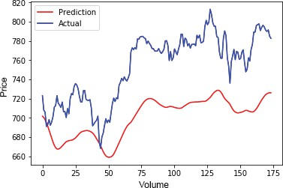

Figure 4: Plot of Actual and Predicted Trends Using LSTM

The efficiency of the LSTM-based model is notable, as the prediction closely approximates the real trend over extended periods of time. The model achieved a Train Score of 0.00106 MSE (0.03 RMSE) and a Test Score of 0.00875 MSE (0.09 RMSE). It is observed that increased training and larger dataset sizes contribute to higher accuracy. Overall, the LSTM Model demonstrated greater accuracy compared to the Regression-based Model.

CONCLUSION

This paper aimed to enhance the accuracy and reliability of predicting future stock prices through the application of machine learning techniques. The researchers' primary contribution was the introduction of the novel LSTM Model for stock price determination.

Both techniques showcased improvements in prediction accuracy, with the LSTM model demonstrating superior efficiency. These findings are encouraging and suggest that achieving more accurate and efficient stock market predictions is feasible through machine learning methodologies.

For future endeavors, augmenting the stock market prediction system's accuracy could entail leveraging larger datasets than the current one. Exploring other emerging machine learning models to gauge their accuracy rates is also warranted. Incorporating sentiment analysis through machine learning, particularly focusing on how news influences stock prices, holds promise for further research. Moreover, exploring additional deep learning-based models for prediction purposes could yield valuable insights.

# REFERENCES

1. M. Usmani, S. H. Adil, K. Raza, and S. S. A. Ali, "Stock market prediction using machine learning techniques," in Proceedings of the 2016 3rd International Conference on Computer and Information Sciences (ICCOINS), Kuala Lumpur, 2016, pp. 322-327.
2. K. Raza, "Prediction of Stock Market performance by using machine learning techniques," in Proceedings of the 2017 International Conference on Innovations in Electrical Engineering and Computational Technologies (ICIEECT), Karachi, 2017, pp. 1-1.
3. H. Gunduz, Z. Cataltepe, and Y. Yaslan, "Stock market direction prediction using deep neural networks," in Proceedings of the 2017 25th Signal Processing and Communications Applications Conference (SIU), Antalya, 2017, pp. 1-4.
4. M. Billah, S. Waheed, and A. Hanifa, "Stock market prediction using an improved training algorithm of neural network," in Proceedings of the 2016 2nd International Conference on Electrical, Computer & Telecommunication Engineering (ICECTE), Rajshahi, 2016, pp. 1-4.
5. H. L. Siew and M. J. Nordin, "Regression techniques for the prediction of stock price trend," in Proceedings of the 2012 International Conference on Statistics in Science, Business and Engineering (ICSSBE), Langkawi, 2012, pp. 1- 5.
6. K. V. Sujatha and S. M. Sundaram, "Stock index prediction using regression and neural network models under non-normal conditions," in Proceedings of INTERACT-2010, Chennai, 2010, pp. 59-63.
7. S. Liu, G. Liao, and Y. Ding, "Stock transaction prediction modeling and analysis based on LSTM," in Proceedings of the 2018 13th IEEE Conference on Industrial Electronics and Applications (ICIEA), Wuhan, 2018, pp. 2787-2790.
8. T. Gao, Y. Chai, and Y. Liu, "Applying long short-term memory neural networks for predicting stock closing price," in Proceedings of the 2017 8th IEEE International Conference on Software Engineering and Service Science (ICSESS), Beijing, 2017, pp. 575-578.
9. K. A. Althelaya, E. M. El-Alfy, and S. Mohammed, "Evaluation of bidirectional LSTM for short- and long-term stock market prediction," in Proceedings of the 2018 9th International Conference on Information and Communication Systems (ICICS), Irbid, 2018, pp. 151-15